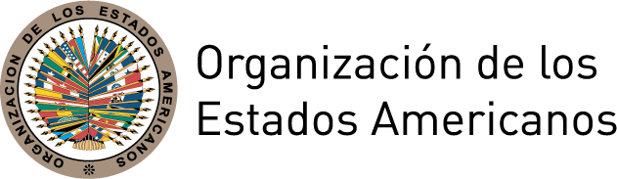
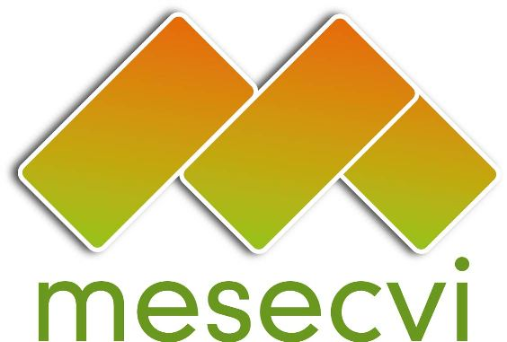

MESECVI Communiqué 03/2011-SP

In search of an integrated response to HIV and violence against women in Central America

Media Contact: Hilary Anderson, Specialist, Inter-American Commission of Women
handerson@oas.org, 1-202-458-33062

[Washington,DC, July 29th 2011] The Inter-American Commission of Women (CIM) at the Organization of American States has begun a project that aims to provide an integrated response to the spread of HIV among women and violence them; two different epidemics that have a lot in common. According to the Joint United Nations Programme on HIV/AIDS (UNAIDS), the risk of contracting HIV can be up to three times higher for women who are victims of violence. Research conducted into the links between HIV and violence against women (VAW) indicates that forced sex, challenges to negotiating condom use and exposure to violence from an early age increase women’s vulnerability to HIV infection.

Similarly, a number of studies conducted over the last ten years have confirmed that women who are already HIV positive are more often victims of violence and discrimination than non-infected women.

In recent years, HIV infection has increased among women at an alarming rate in various regions of the world, including Central America. The most recent UNAIDS report states that in Guatemala, the number of HIV-infected women doubled between 2001 and 2009 (from 9,600 to 20,000 cases), and in El Salvador the number increased from 8,000 to 11,000 over the same period. The Ministry of Health of Panama points out that the feminization of HIV is increasing.

At the same time, rates of violence against women are worrying, to say the least. According to national surveys conducted in the three countries, in Panama, 13.8% of women indicated that they has suffered some type of violence at the hands of their partner, while the figures reached 25.2% of women in Guatemala and 46.5% of women in El Salvador.

The CIM project will support the development of policy and programme models that contribute to providing integrated responses to HIV and VAW in the areas of prevention, care, social support and the protection of human rights. The project will bring together government representatives, service providers, civil society groups, including networks of women living with HIV and survivors of violence, international organizations, media and other key stakeholders. The progress of the project will be discussed and publicized through the recently-launched Community of Practice on HIV and VAW (www.vih-violencia.org, only available in Spanish), a virtual space that was created to support the exchange of ideas and information and the collective construction of knowledge.
_______________________________________

The Organization of American States (OAS) is the world’s oldest regional organization, dating back to the First International Conference of American State (October 1889 to April 1890). It was established in 1948 with the aim of achieving among the States of the Americas “an order of peace and justice, to promote their solidarity, to strengthen their collaboration, and to defend their sovereignty, their territorial integrity, and their independence.” The OAS prioritizes four pillars - democracy, human rights, security, and development – that support each other and are intertwined through political dialogue, inclusiveness, cooperation, and legal and follow-up instruments that provide the OAS with the tools to maximize its work in the Hemisphere.

Established in 2004, the Follow-up Mechanism to the Belem do Para Convention (MESECVI) was created as an independent, consensus-based system to examine the progress made by the 32 States Party in achieving the objectives of the Convention.
For more information, visit MESECVI at: http://www.oas.org/mesecvi

UNAIDS, Women, Girls and HIV Fact Sheet (Geneva: UNAIDS, 2010).Pag 1 http://data.unaids.org/pub/FactSheet/2010/20100302_fs_womenhiv_en.pdf
http://www.sph.unc.edu/?option=com_profiles&profileAction=ProfDetail&pid=711824096
Ver referencia No. 1. Pag 203
Ministerio de Salud de Panamá - Dirección General de Salud Pública Programa Nacional de VIH y SIDA. (2006). Plan Estratégico Multisectorial de VIH y SIDA. Prioridades 2007-2010. Panamá: Retrieved from http://www.womenandaids.net/CMSPages/GetFile.aspx?guid=6a3aab85-d95e-4b4d-b819-aa63ec769fc0.
Encuesta Nacional de Salud Sexual y Reproductiva de 2009 del Fondo de Población de Naciones Unidas (UNFPA). Pag 15. http://media.gestorsutil.com/UNFPA_web/48/noticias/docs/0940048001286925341.pdf
CIM/OEA, Comisión Interamericana de Mujeres. Integración de Políticas y Programas de VIH y Violencia contra la Mujer Desde un Enfoque de Derechos Humanos en Centroamérica. Boletín Informativo No 4. Pag 1. http://portal.oas.org/LinkClick.aspx?fileticket=BMALScISe38%3d&tabid=1792
Encuesta Nacional de Salud Familiar de 2008 (FESAL-2008). Pag 48. http://elsalvador.usaid.gov/uploaded/mod_documentos/FESAL2009-InformeResumido_1.pdf

